Question 7

Describe how you would configure a basic LAN interface using the ip command in Linux.

Solution

First check the available interface using ip link show command

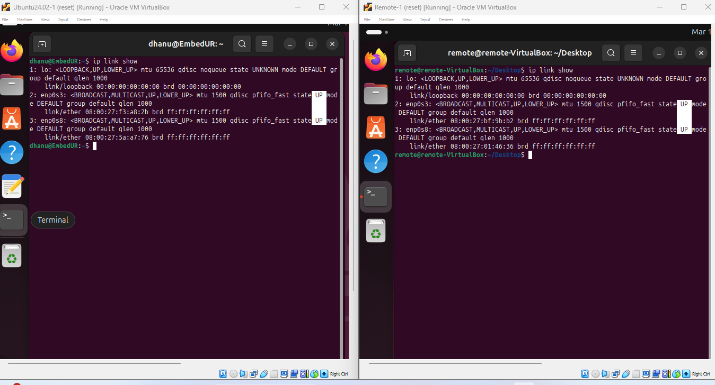

The next step is to assign static ip address. But before assigning static ip address we need to disable and stop networkmanager. The main reason behind this is the system will not accept static. The network manager will automatically remove it because of dhcp and previous arp cache data.

To do this use  
 sudo systemctl disable NetworkManager

Sudo systemctl stop NetworkManager

Now assign static ip for your device (make sure both ip’s are unique) and cross check it

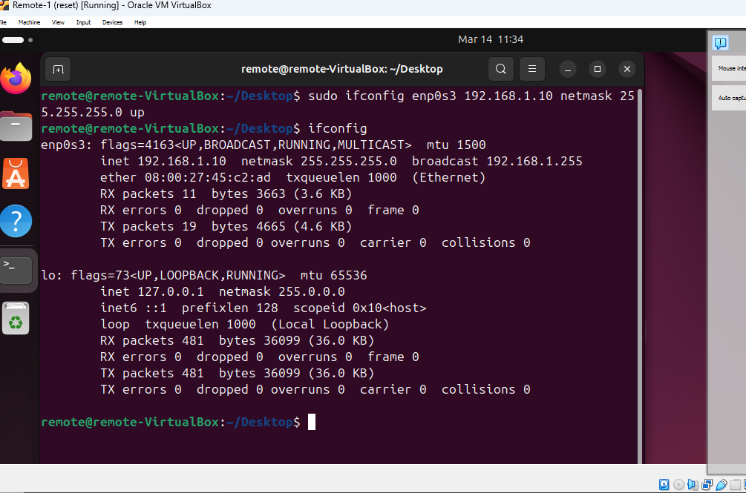

Once you done setting static IP bring the interface up by using

sudo ip link set enp0s3 up

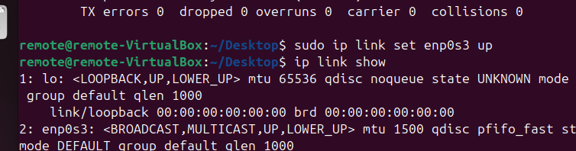

Now check whether route is available or not. If not add one with the command

sudo ip route add default via 192.168.1.0

Now try to ping the another system with ping commad

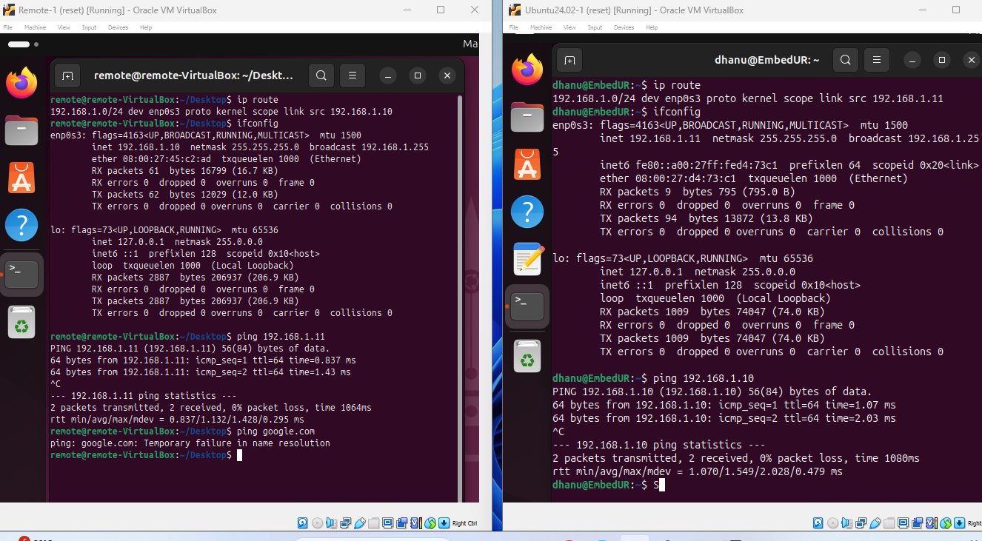

As you can see that we were able to ping another system successfully but we are not able to ping google.com. Which tells that we successfully made a lan network with two pc and a switch

GNS3 Network Structure

